EGB241 – Electromagnetics and Machines
DC Motor Building Assignment (40%)

Technical Design and Evaluation of a
Permanent Magnet DC Motor

Group 20

Krystian Rozanski (n12455466)
Darcy Sheppard (n12466255)
Paddy Dale (n12427462)
Jakob Sahlberg (n12175048)
Jamie Fowler (n12363618)

Semester 1, 2026
Queensland University of Technology

Table of Contents
Table of Contents 1
1. Executive Summary 1
2. Introduction and Application Context 1
2.1 Project Scope 1
2.2 Selected Application: Compact Desktop Cooling Fan 1
2.3 Report Structure 1
3. Project Brief and Compliance 1
3.1 Design Constraints 1
3.2 Requirements Traceability 1
4. Concurrent Engineering Approach 1
4.1 Workstream Decomposition 1
4.2 Interface Management 1
4.3 Limits of the Process 1
5. Design Phase 1
5.1 Design Methodology 1
5.2 Back-Iron Design and Material Selection 1
5.3 Rotor Geometry and Structural Dimensions 1
5.4 Winding Strategy and Conductor Selection 1
5.5 Magnet Selection and Alternative Evaluation 1
5.6 Electromagnetic Performance Predictions 1
5.7 Summary of Design Parameters 1
5.8 Winding and Commutator Connection Schedule 1
6. Computational Modelling 1
6.1 Excel Design Interface 1
6.2 MATLAB Forward Euler Simulation 1
6.2.1 Governing Equation 1
6.2.2 Forward Euler Implementation 1
6.2.3 Rotor Moment of Inertia 1
6.2.4 Simulation Scenarios 1
6.3 Sensitivity Analysis: Speed-Torque Characteristics Across Magnet Options 1
6.4 Simulation Results 1
7. Construction and Testing 1
7.1 Rotor and Winding Construction 1
7.2 Commutator and Brush Assembly 1
7.3 Magnet and Back-Iron Installation 1
7.4 Quality Assurance 1
7.5 Dynamometer Test 1
8. Critical Evaluation 1
8.1 Comparison of Predicted and Measured Performance 1
8.2 Root-Cause Analysis 1
8.3 Process-Level Analysis 1
8.4 What the Test Confirmed 1
8.5 Impact of Absent Intermediate Testing Sessions 1
9. Recommendations and Future Work 1
9.1 Structured Intermediate Testing Protocol 1
9.2 Future Work 1
10. Reflective Review 1
11. Conclusion 1
References 1
Appendix A, Initial Design Sketches 1
Appendix B, MATLAB Source Code 1

1. Executive Summary
This report documents the design, construction, and performance evaluation of a brushed permanent magnet DC (PMDC) motor by Group 20, completed as part of EGB241 – Electromagnetics and Machines. The motor was designed as a scaled prototype of the drive unit for a compact desktop cooling fan, selected for its compatibility with the project safety constraints: a 30 V supply ceiling, a 5 A current limit, and a 2000 RPM no-load speed limit.
The design was developed across two computational tools. An Excel spreadsheet sized the rotor, winding, and magnetic circuit, with all five compliance checks passing: 44.17 m of wire (within the 45 m limit), a predicted no-load speed of 1395 RPM, a stall current of 1.68 A, and a stall torque of 20.5 mN·m. A MATLAB Forward Euler simulation then modelled the transient behaviour under a standard 6.09 V supply and a current-limited 5.28 V scenario.
The physical motor produced measurable rotation under load and self-started successfully. However, an assembly error, the back-iron yoke and stabilising plate were installed in inverted positions, severely disrupted the magnetic return path. The motor drew 7.9 A at 2.8 V to produce only 195 RPM, giving an overall efficiency of 0.134% against the predicted 40%. Root-cause analysis confirmed that the winding, commutation, and electromagnetic design were sound. Recommendations focus on assembly-stage quality controls, including labelled components and illustrated step-by-step checklists, to prevent recurrence.

2. Introduction and Application Context

2.1 Project Scope
The EGB241 DC Motor Building Assignment required each group to design, build, and demonstrate a brushed commutated DC motor capable of driving a loaded dynamometer under controlled laboratory conditions (Queensland University of Technology, 2025). The project was structured as a two-part exercise: a computational design phase using Excel and MATLAB, followed by physical construction and testing. This structure was intentional, framing the assignment as a complete engineering workflow where analytical predictions inform material selection and assembly, and measured results validate or challenge the underlying model.

2.2 Selected Application: Compact Desktop Cooling Fan
The motor was designed as a scaled prototype of the drive unit for a compact desktop cooling fan, typically rated between 2 W and 10 W and operating between 1000 and 2500 RPM. This application was selected because its operating envelope aligns with the assignment constraints: the 2000 RPM no-load speed limit, the 5 A current ceiling, and the requirement for self-starting against a small but non-trivial friction load.
Commercial desktop fans in this class are typically driven by either brushless DC (BLDC) motors with electronic commutation or by simpler brushed PMDC motors with mechanical commutation (Chapman, 2012; Hughes, 2019). The brushed PMDC variant remains commercially relevant where cost dominates, and operating duty cycles are low enough that brush wear does not constrain product lifetime.
Fan loads exhibit torque demand that scales approximately with the square of rotational speed ($τ∝ω^{2}$), a consequence of the fan affinity laws (Hughes, 2019). The drooping torque-speed curve of a PMDC motor provides natural matching to this load profile, offering intrinsic overspeed protection without requiring external control (Mohan, Undeland & Robbins, 2003).

3. Project Brief and Compliance

3.1 Design Constraints
The assignment brief specified the following constraints, which governed every design and construction decision (Queensland University of Technology, 2025):
- Brushed and commutated topology, supplied by DC with no active power-electronic controllers.
- A minimum of three and a maximum of eight coils, full-pitched and lap-wound.
- Maximum conductor length of 45 m.
- Continuous current draw not exceeding 5 A; terminal voltage not exceeding 30 V.
- No-load speed not exceeding 2000 RPM.
- Sufficient electromagnetic torque to overcome the dynamometer's internal friction of 0.845 mN·m.
- Self-starting capability (design goal rather than hard requirement).
- Excitation provided by exactly two permanent magnets (two-pole field configuration).
- Construction undertaken entirely by group members using the QUT-supplied kit and self-fabricated parts.

3.2 Requirements Traceability
Table 1 maps each major brief requirement to the section and artefact demonstrating compliance.

Requirement | Compliance Evidence | Result
<= 45 m wire length | Section 5.3, Excel flag | 44.17 m
<= 5 A current draw | Sections 5.4, 6.2.4 | 1.68 A design; 4.99 A (regulated sim)
<= 30 V terminal voltage | Section 5.6, Excel flag | 1.78 V design
<= 2000 RPM no-load speed | Section 5.6, Excel flag | 1395 RPM design
>= 0.845 mN·m starting torque | Section 5.6, Excel flag | 20.5 mN·m predicted (~24x margin)
Brushed, commutated topology | Sections 5.4, 7.2 | 8-segment commutator, two-brush
3-8 coils, lap winding | Sections 5.4, 5.8 | 8 coils, lap wound
Two permanent magnets | Section 5.5 | Magnet #3495, pair
Self-starting | Section 7.5 | Started under load
Group-built construction | Section 7 | All construction by group
Excel: $K$, $R_{A}$, $n$, $τ$, $P$, data validation, static refs | Section 6.1 | All present
MATLAB: input/disp/sprintf, multi-plot figures | Section 6.2, App. B | All present
Table 1: Mapping of brief requirements to report evidence and demonstrated compliance.

4. Concurrent Engineering Approach
The team adopted a concurrent rather than sequential engineering workflow to compress the project timeline and ensure that downstream constraints (manufacturability, assembly tolerances, brush alignment, magnet retention) informed upstream decisions (rotor geometry, winding configuration, magnet selection) from the outset. Three parallel workstreams were defined at the project start and maintained throughout.

4.2 Interface Management
The principal advantage of concurrent execution is parallel progress; its principal risk is that decisions made independently in one workstream invalidate assumptions in another. Three mechanisms were used to mitigate this risk.
First, the Excel design interface was treated as the canonical specification document. Any change to a design parameter was made in the Excel sheet first, where dependent calculations and compliance flags updated automatically. The mechanical and construction workstreams consumed these values directly rather than working from independent estimates.
Second, weekly synchronisation reviews were held at which each workstream presented its current state, flagged blocking dependencies, and confirmed the values it was consuming from others. These reviews surfaced the 90-degree commutator-to-coil alignment issue (Section 7.2) during the construction phase, allowing correction before testing rather than during.
Third, design decisions with the highest cost of rework, magnet selection, wire gauge, lamination type, were frozen early. This allowed the mechanical and construction workstreams to proceed in parallel without waiting for further design iterations.

4.3 Limits of the Process
The concurrent workflow was effective at the design and computational levels but proved insufficient at the design-to-build interface, as discussed in Section 8.3. The back-iron orientation error arose at the handover between Workstream B (which specified the back-iron geometry) and Workstream C (which physically installed it), in a region the weekly reviews did not explicitly cover. This is the principal driver of the recommendations in Section 9.

5. Design Phase
Throughout this design, all major parameter choices, including wire gauge and magnet selection, were made with torque maximisation as the primary objective. This priority arose because the practical assembly uses imperfect ball bearings, an aluminium casing with inherent rotational drag, and the dynamometer whose internal friction (0.845 mN·m) represents a significant fraction of the expected output torque. The design was therefore biased toward the highest achievable stall torque to ensure reliable self-starting under realistic conditions that exceed the idealised friction figure specified in the brief.
Friction reduction is also identified as a high-priority future improvement. Substituting the standard ball bearings with PTFE-coated or ceramic rolling-element bearings (Hamrock, Schmid & Jacobson, 2004) would lower the static breakaway threshold and extend the achievable operating speed range. Reducing casing bore surface roughness and using a low-viscosity lubricant at the shaft-bearing interface would provide further gains, complementing the electromagnetic optimisations listed in Table 9.

5.1 Design Methodology
The design phase progressed from a fixed set of physical constraints: the supplied 8-slot, 16-lamination rotor stack, two available magnet families, and an AWG 18-29 wire range, through to a parameterised electromagnetic specification. At each major decision point, at least two viable alternatives were identified, compared on electromagnetic performance, manufacturability, cost of rework, and constraint compliance, and the rationale for the chosen option recorded.

5.2 Back-Iron Design and Material Selection
The flux density across the air gap is governed by the magnetic circuit. For a permanent magnet in its linear demagnetisation region, the air-gap flux density is:
$$B_{gap} = \frac{B_{r}}{1 + μ_{r}·\frac{g}{l_{m}}}$$
where $B_{r}$ is the remnant flux density, $μ_{r}$ is the magnet relative recoil permeability, g is the air gap, and $l_{m}$ is the magnet height. For the #3495 magnet ($B_{r}$≈0.371 T, μr≈1.05, g 2.5 mm, $l_{m}$ 8 mm), this gives $B_{gap}$≈0.279 T, consistent with the 50% total-flux-leakage factor used in the design.
The back-iron provides the low-reluctance return path for magnetic flux generated by the permanent magnets, maximising the flux density crossing the rotor air gap and minimising leakage flux that does not link the armature winding (Fitzgerald, Kingsley & Umans, 2003). The reluctance of the magnetic circuit is governed by:
$$R = \frac{l}{μ_{0}μ_{r}A}$$
where l is the path length, A is the cross-sectional area, and $μ_{r}$ is the relative permeability. Minimising reluctance, by using a high $μ_{r}$ material and keeping the air gap small, directly maximises the flux linkage with the armature. Three options were evaluated:

Option A: 60.3 mm stainless steel pipe stock. The diameter closely matched the 60 mm rotor outer diameter. Rejected because widely available stainless-steel pipe has poor magnetic permeability ($μ_{r}$ < 100) compared to mild steel ($μ_{r}$ > 1000), and the tight dimensional tolerance would require precision machining not feasible within the project budget.
Option B: Mild steel pipe saddles. Available at low cost with the high relative permeability required. The principal disadvantages were the galvanised zinc coating (non-magnetic, requiring removal by sanding) and limited malleability, making it difficult to shape precisely to the rotor outer surface. Viable but not ideal.
Option C: Steel laminations (selected). Laminated construction provides precise industry-grade cutting, accurate thickness control, and good malleability, allowing the back-iron to be shaped to the required dimensions without specialised tooling. The gain in geometric precision and compatibility with the rest of the laminated rotor assembly justified the cost increase.
A back-iron thickness of 3.6 mm was chosen, consistent with the general engineering guideline of 5-10% of core diameter (Fitzgerald, Kingsley & Umans, 2003). This avoids magnetic saturation at the design peak flux density of 1.3 T. The resulting air gap between the back-iron inner face and the rotor outer surface was approximately 2.5 mm, larger than the ideal 1 mm target but acceptable given hand-assembled construction. However, for future designs with better manufacturing equipment Option A would provide an improvement towards the back iron design, especially if the pipe has significant thickness and remains unsaturated.

5.3 Rotor Geometry and Structural Dimensions
Note that $R_{avg}$ is approximated as the mean of the outer rotor radius and shaft radius, slightly overestimating the true conductor mid-radius. This approximation is compensated by the conservative 0.6 packing factor, which keeps the effective turn count well below the slot geometry maximum. The combined impact on total wire length is within the 1.9% margin against the 45 m constraint.
The rotor geometry was derived from the 8-slot, 16-lamination stack supplied in the QUT kit. The rotor stack length is:
$$L_{R} = 16×1.2 mm = 19.2 mm$$
The average winding radius, positioned at the midpoint of the slot depth, is:
$$R_{avg} = \frac{\left(R_{T} + R_{S}\right)}{2} = \frac{\left(30 + 15\right)}{2} = 22.5 mm$$
For a full-pitched lap winding with a 180-degree pitch, the chord length spanning one pole pitch is:
$$L_{c} = 2R_{avg}·sin\left(90°\right) = 2×22.5 = 45 mm$$
The length of a single wire turn, accounting for two active conductor segments across the rotor face and two end-turn segments spanning the stack length, is:
$$L_{N} = 2L_{c} + 2L_{R} = 2(45) + 2(19.2) = 128.4 mm$$
It should be noted that this calculation assumes all turns lie on the same geometric plane. In practice, turns in a slot stack radially, so conductors wound later sit at a marginally larger radius, extending their end-turn length slightly. The effect is small relative to the total wire length but means actual wire consumption is slightly above the geometric estimate. With 8 coils and 43 turns per coil, the total wire length is:
$$L_{W} = C·N_{C}·L_{N} = 8×43×128.4 mm = 44 169.6 mm ≈ 44.17 m$$
This satisfies the 45 m constraint with a 1.9% margin. The 43-turn count was validated against the available slot cross-section: with a usable slot area of 120 mm² and an assumed packing factor of 0.6, the maximum AWG 18 turns per slot is 43, the densest achievable configuration for this lamination geometry.

5.4 Winding Strategy and Conductor Selection
It should also be noted that the QUT-supplied commutator uses brass segments rather than the copper standard in commercial motors. Brass has approximately 40% lower electrical conductivity than copper, and it’s harder surface produces higher contact resistance with carbon brush stock (Hughes, 2019). This contributes additional losses beyond the 1 Ω brush-resistance estimate in the armature resistance model, and upgrading to a copper commutator is identified in the recommendations as a medium-priority improvement.
Five wire gauges in the AWG 18-29 range were available from the QUT store. The principal trade-off is between turn count (which raises back-EMF and torque) and conductor cross-section (which lowers resistance and reduces ohmic losses). Table 2 summarises the principal candidates.

AWG | Dia. (mm) | Area (mm²) | Res. (mΩ/m) | Max turns/slot | Notes
18 | 1.024 | 0.823 | 20.95 | 43 | Selected, lowest resistance, maximises current capacity
19 | 0.912 | 0.653 | 26.42 | 55
20 | 0.812 | 0.518 | 33.31 | 69 | Higher turn count; 45 m cap limits benefit
21 | 0.723 | 0.41 | 42 | 87
22 | 0.644 | 0.326 | 52.96 | 110 | Elevated resistance reduces stall current and torque
23 | 0.573 | 0.258 | 66.79 | 139
24 | 0.511 | 0.205 | 84.22 | 175 | Ohmic losses become dominant
25 | 0.455 | 0.162 | 106.2 | 222
26 | 0.405 | 0.129 | 133.9 | 279 | Thermal margin severely reduced at 5 A
27 | 0.361 | 0.102 | 168.9 | 352
28 | 0.321 | 0.081 | 212.9 | 444
29 | 0.286 | 0.0642 | 268.5 | 560
Table 2: Comparative properties of AWG candidates. Max turns per slot assumes a 0.6 packing factor in the 120 mm² slot area shared between two coil sides.

AWG 18 was selected for two primary reasons. First, it has the lowest resistance per unit length of all available gauges, maximising the current deliverable to the armature at a given supply voltage and therefore the stall torque, which is critical given that overcoming the dynamometer's friction was an anticipated challenge. Second, the 45 m wire-length constraint caps the total turn count for any gauge well below the geometric slot capacity for AWG 20 and below; the 43-turn AWG 18 configuration is the only one that reaches both the wire-length and slot-packing limits simultaneously, making it the densest feasible winding.
Maximising the number of slots to 8 further benefits the motor: 8 full-pitched coils increase the total number of armature conductors Z, which improves both the back-EMF constant and the torque constant. More conductors also smooth the ripple in the electromagnetic torque waveform, producing more continuous rotation at low speed (Chapman, 2012).
A simplex lap winding was used throughout, consistent with the two-pole, eight-coil topology. Lap winding produces two parallel current paths through the armature (a = 2), distributing the armature current and reducing peak current density in any individual conductor (Chapman, 2012). The total number of armature conductors is:
$$Z = 2·C·N_{C} = 2×8×43 = 688$$
The armature resistance accounts for the wire resistance across two parallel current paths plus a 1 Ohm brush contact resistance specified in the design guidelines (Queensland University of Technology, 2025):
$$R_{a} = 1 + \frac{L_{W}·ρ}{4} = 1 + \frac{\left(44.17×0.02095\right)}{4} = 1.0578 Ω$$
The dominance of the 1 Ohm brush resistance over the 0.058 Ohm wire contribution highlights that brush contact quality, rather than winding resistance, is the principal electrical loss mechanism, a finding reinforced by the test results in Section 7.5.

5.5 Magnet Selection and Alternative Evaluation
Post-test analysis reveals the 50% leakage assumption was non-representative under the inverted back-iron condition. Back-calculating from the test data:
$$Φ_{link,act} = \frac{τ_{out}}{K_{2}·I_{a}} = \frac{1.45×{10}^{-3}}{109.5×7.9} = 1.67×{10}^{-6} Wb ≈ 0.00167 mWb$$
This is approximately 1.5% of the design value of 0.111 mWb, indicating an effective leakage factor of 99.25% rather than the assumed 50%. This confirms near-total flux collapse. The 50% assumption remains appropriate for the correctly assembled motor and should be re-verified after the build correction (Recommendation 1, Table 9).
Five permanent magnet options were available from the QUT store. Magnet selection was the most consequential single design choice because the air-gap flux density is the dominant driver of both the back-EMF constant and the torque constant. The relevant figure of merit is not the flux density per unit area but the total flux through the pole face, $Φ$ = B * A (Chapman, 2012). Table 3 lists the physical properties of each candidate.

Code | B (G) | L (mm) | W (mm) | H (mm) | A (cm²) | $Φ$(mWb) | Status
#2522 | 1400 | 50 | 20 | 12.7 | 10.000 | 0.14000 | Rejected
#3495 | 3709 | 40 | 15 | 8 | 6.000 | 0.22254 | Selected
#3460 | 2408 | 25 | 12.5 | 3.5 | 3.125 | 0.07525 | Rejected
#3470 | 3625 | 25 | 12.5 | 6.0 | 3.125 | 0.11328 | Rejected
LM1614 | 580 | 20 | 15 | 5.0 | 3.000 | 0.01740 | Rejected
Table 3: Physical properties of the five available permanent magnets. The chosen magnet (#3495) is highlighted in blue.

Table 4 projects these properties into the motor operating regime. A 50% flux-leakage factor was assumed, consistent with the 2.5 mm air gap and imperfect magnetic path geometry (Fitzgerald, Kingsley & Umans, 2003). The linked flux is $Φ_{linkage}$ = 0.5 * $Φ_{total}$.

Code | $Φ_{linkage}$ (mWb) | $n_{max}$ (RPM) | $τ_{stall}$(mN·m) | Speed Compliance | Status
#2522 | 0.0700 | 2217 | 12.90 | Not compliant | Rejected
#3495 | 0.1113 | 1395 | 20.50 | Compliant | Selected
#3460 | 0.0376 | 4124 | 6.93 | Not compliant | Rejected
#3470 | 0.0566 | 2740 | 10.44 | Not compliant | Rejected
LM1614 | 0.0087 | 17836 | 1.60 | Not compliant | Rejected
Table 4: Predicted electromagnetic performance of each magnet at $V_{T}$ = 1.78 V, with $K_{1}$ = 11.47, $K_{2}$ = 109.5 N·m/(Wb·A), and $R_{A}$ = 1.0578 Ohm.

Magnet #3495 is the only candidate satisfying the 2000 RPM no-load speed constraint at the design voltage, and it also produces the highest predicted stall torque (20.5 mN·m), exceeding the dynamometer friction torque by a factor of approximately 24. A key observation is that magnets #3495 and #3470 have surface flux densities within 3% of each other (3709 G vs 3625 G), yet their predicted no-load speeds differ by a factor of two. The difference is driven entirely by pole-face area: #3495's 6 cm² face produces almost twice the total flux of #3470's 3.125 cm² face. The relevant figure of merit is therefore the total flux BA, not the flux density alone.

5.6 Electromagnetic Performance Predictions
The motor constants are derived from the armature geometry (Chapman, 2012):
$$K_{1} = \frac{Z}{60} = \frac{688}{60} = 11.47$$
$$K_{2} = \frac{Zp}{2πa} = \frac{\left(688×2\right)}{\left(2π×2\right)} = 109.5 N·m (Wb·A)⁻¹$$
With $Φ_{linkage}$ = 0.11127 mWb and design terminal voltage $V_{T}$ = 1.78 V, the predicted no-load speed is:
$$n_{max} = \frac{V_{T}}{K_{1}·Φ_{linkage}} = \frac{1.78}{11.47×0.11127×{10}^{-3}} = 1395 RPM$$
This satisfies the 2000 RPM ceiling with a 30% margin. The stall current and stall torque are:
$$I_{max} = \frac{V_{T}}{R_{a}} = \frac{1.78}{1.0578} = 1.683 A$$
$$τ_{max} = K_{2}·Φ_{linkage}·I_{max} = 109.5×0.11127×{10}^{-3}×1.683 = 20.5 mN·m$$
Peak mechanical output power and predicted efficiency at the peak-power operating point (half no-load speed):
$$P_{max} = \frac{{V_{T}}^{2}}{4R_{a}} = \frac{{1.78}^{2}}{4×1.0578} = 0.749 W$$
$$P_{actual} = P_{max}×\left(1-0.20\right) = 0.599 W$$
$$P_{in} = V_{T}·I_{a} = 1.78×0.841 = 1.498 W$$
$$η = \frac{P_{actual}}{P_{in}}×100 = \frac{0.599}{1.498}×100 = 40.0\%$$

5.7 Summary of Design Parameters
Table 5 consolidates the final design parameters and predicted performance metrics used across both computational artefacts.

Parameter | Symbol | Value | Unit
Rotor stack length | $$L_{R}$$ | 19.2 | mm
Average winding radius | $$R_{avg}$$ | 22.5 | mm
Number of coils | $$C$$ | 8 | --
Turns per coil | $$N_{C}$$ | 43 | --
Total conductors | $$Z$$ | 688 | --
Parallel paths | $$a$$ | 2 | --
Total wire length | $$L_{W}$$ | 44.17 | m
Wire gauge | AWG | 18 | --
Armature resistance | $$R_{A}$$ | 1.0578 | Ohm
Magnet flux linkage | $$Φ_{linkage}$$ | 0.1113 | mWb
EMF motor constant | $$K_{1}$$ | 11.47 | --
Torque motor constant | $$K_{2}$$ | 109.50 | N·m/(Wb·A)
Design terminal voltage | $$V_{T}$$ | 1.78 | V
No-load speed (design) | $$n_{max}$$ | 1395 | RPM
Stall torque (design) | $$τ_{max}$$ | 20.5 | mN·m
Peak actual power output | $$P_{actual}$$ | 0.599 | W
Predicted peak efficiency | $$η$$ | 40.0 | %
Table 5: Consolidated design parameter summary derived from the Group 20 Excel interface.

5.8 Winding and Commutator Connection Schedule
The simplex lap winding connects the finish end of each coil to the start riser of the subsequent coil, producing two closed parallel paths through the armature with one brush pair at the magnetic neutral axis (Chapman, 2012). Table 6 gives the connection schedule for the eight-coil, full-pitched configuration.

Coil | Start Slot | Finish Slot | Start Riser | Finish Riser
1 | Slot 1 | Slot 5 | Riser 1 | Riser 2
2 | Slot 2 | Slot 6 | Riser 2 | Riser 3
3 | Slot 3 | Slot 7 | Riser 3 | Riser 4
4 | Slot 4 | Slot 8 | Riser 4 | Riser 5
5 | Slot 5 | Slot 1 | Riser 5 | Riser 6
6 | Slot 6 | Slot 2 | Riser 6 | Riser 7
7 | Slot 7 | Slot 3 | Riser 7 | Riser 8
8 | Slot 8 | Slot 4 | Riser 8 | Riser 1
Table 6: Simplex lap winding connection schedule.

6. Computational Modelling

6.1 Excel Design Interface
The Excel workbook is organised into distinct input and output sections with explicit unit annotation. Geometric inputs (rotor length, winding radius, pole count) are entered in the upper block; winding inputs (gauge, coil count, turns per coil) follow; and dependent outputs (conductor count, chord length, total wire length, motor constants, armature resistance, and predicted performance) are computed automatically in clearly labelled blocks.
The sheet uses XLOOKUP to dynamically retrieve conductor diameter, resistance, and cross-section from the WIRES reference table based on the selected AWG, and an IF function to populate magnet flux data from the MAGNETS table based on a drop-down selector, satisfying the data validation requirement. Custom cell formatting displays units adjacent to each calculated value, with colour-coded compliance flags (green for CORRECT, red for WRONG) using conditional formatting rules. All physical constants and table references use absolute cell addresses (e.g., $B$4) to prevent accidental offset when copying formulas, satisfying the static cell reference requirement.
Five compliance flags are evaluated at the foot of the sheet and all return CORRECT with the final design parameters: wire length < 45 m, current < 5 A, voltage < 30 V, speed < 2000 RPM, and stall torque > 0.845 mN·m. The structured separation of inputs, intermediate calculations, and final outputs allows what-if analysis on any single parameter with immediate propagation to compliance and performance outputs.

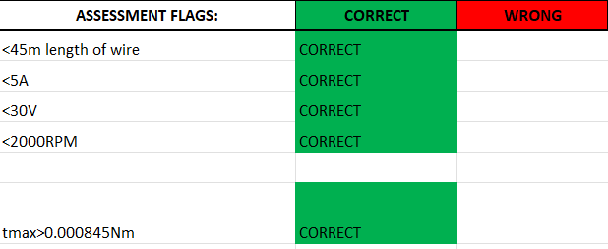
Figure 1: Group 20 Excel design interface. All five compliance flags return CORRECT at the final design parameters.

6.2 MATLAB Forward Euler Simulation

6.2.1 Governing Equation
The dynamic behaviour of the PMDC motor follows Newton's second law applied to the rotating mechanical system:
$$J·\frac{dω}{dt} = τ_{ind}-τ_{load}$$
where $J$ is the rotor moment of inertia (kg·m²), $ω$ is angular velocity (rad/s), $τ_{ind}$ is electromagnetic torque (N·m), and tau_load is the applied load torque (N·m). Substituting $ω$ = $n$ * 2*$π$/60 and expressing in RPM/s gives the governing ODE:
$$\frac{dn}{dt} = \frac{60}{2π}·\frac{τ_{ind}-τ_{load}}{J} ≡ α$$
The coupling between the electrical and mechanical domains is:
$$E_{a} = K_{1}·Φ·n$$
$$I_{a} = \frac{V_{s}-E_{a}}{R_{a}}$$
$$τ_{ind} = K_{2}·Φ·I_{a}$$

6.2.2 Forward Euler Implementation
The Forward Euler scheme advances the solution by a fixed time step dt using the derivative at the current step:
$$n\left[k\right] = n\left[k-1\right] + α\left[k-1\right]·Δt$$
The simulation ran over a 30 s window with 1000-time steps:
$$Δt = \frac{t_{sim}}{N} = \frac{30}{1000} = 0.030 s$$
This step size is well below the smallest mechanical time constant of the system ($R_{A}$ * $J$ / ($K_{1}$ * $K_{2}$ * $Φ^{2}$) ≈ 1.7 s), ensuring numerical stability (Chapra & Canale, 2015). Initial conditions at k = 1 reflect the motor at standstill: $n$ = 0 RPM, $E_{A}$ = 0 V, and $I_{A}$ = $V_{s}$ / $R_{A}$ (stall current with no back-EMF).

6.2.3 Rotor Moment of Inertia
The rotor was modelled as a hollow annular cylinder of composite material, with steel and copper contributions treated separately.
Steel volume: with outer radius $R_{rotor}$ = 30 mm, slot width $W_{slot}$ = 8 mm, slot cross-section $A_{slot}$ = 120 mm², and 8 slots:
$$A_{steel} = π{R_{rotor}}^{2}-π{\left(\frac{W_{slot}}{2}\right)}^{2}-8A_{slot} = 2776-960 = 1816 mm²$$
$$V_{steel} = A_{steel}·L_{R} = 1816×19.2 = 34 867 mm³$$
Copper volume: with AWG 18 conductor diameter $D_{wire}$ = 1.024 mm:
$$V_{copper} = π{\left(\frac{D_{wire}}{2}\right)}^{2}·L_{W} = 0.823×44 169.6 = 36 372 mm³$$
Constituent masses and moment of inertia:
$$m_{steel} = 34 867×7.85×{10}^{-6} = 0.2737 kg$$
$$m_{copper} = 36 372×8.96×{10}^{-6} = 0.3259 kg; m_{rotor} = 0.5996 kg$$
$$J = \frac{1}{2}·m_{rotor}·\left({R_{1}}^{2} + {R_{2}}^{2}\right) = \frac{1}{2}×0.600×\left({0.004}^{2} + {0.030}^{2}\right) = 2.747×{10}^{-4} kg·m²$$
The copper contribution to total rotor mass (54%) marginally exceeds the steel contribution (46%), driven by copper's higher density and the long total wire length.

6.2.4 Simulation Scenarios
Two supply voltage scenarios were simulated to expose the design trade-off between rotational performance and current-limit compliance.
Standard scenario (V_s = 6.09 V). The supply voltage was chosen to position the loaded steady-state speed near the 2000 RPM safety ceiling. With an applied load torque of 40.845 mN·m (40 mN·m applied brake load plus 0.845 mN·m internal friction), the loaded steady-state speed reaches 1993 RPM. This scenario characterises the upper bound of the motor's operating envelope.
Regulated scenario ($V_{s}$ = 5.28 V). The supply voltage was calculated to enforce the 5 A startup current limit:
$$V_{reg} = I_{lim}·R_{a}-0.01 = 5.0×1.0578-0.01 = 5.28 V$$
This caps the stall current at 4.99 A (fully compliant with the brief), at the cost of a reduced steady-state speed of 1358 RPM. This is the operationally valid design point for the physical motor.

6.3 Sensitivity Analysis: Speed-Torque Characteristics Across Magnet Options
The steep torque-speed slope of magnet #3495 is directly relevant to the torque challenge identified in the design priorities: a stiffer speed-torque characteristic provides higher available torque at the low starting speeds where the motor must overcome static friction in the bearings, casing, and dynamometer coupling before transitioning to the speed-dependent friction regime. The three-times-steeper slope compared to the next-best option provides substantially greater margin for reliable self-starting under real-world conditions.
To address the brief's requirement for analysis across different field magnetic flux densities, the steady-state speed-torque characteristic was computed analytically for each magnet at the design terminal voltage. For a PMDC machine in steady state:
$$τ = \frac{K_{2}·Φ_{link}·\left(V_{T}-K_{1}·Φ_{link}·n\right)}{R_{a}}$$
Table 7 lists the resulting no-load speed, stall torque, and characteristic slope for each magnet.

Magnet | $Φ_{linkage}$ (mWb) | $n_{max}$ (RPM) | $$τ_{stall}$$  (mN·m) | Slope (mN·m/1000 RPM) | Compliant
#2522 | 0.0700 | 2217 | 12.90 | 5.82 | No
#3495 | 0.1113 | 1395 | 20.50 | 14.70 | Yes
#3460 | 0.0376 | 4124 | 6.93 | 1.68 | No
#3470 | 0.0566 | 2740 | 10.44 | 3.81 | No
LM1614 | 0.0087 | 17836 | 1.60 | 0.090 | No
Table 7: Analytical speed-torque characteristics across all five available magnets at $V_{T}$ = 1.78 V.

Magnet #3495 is the only speed-compliant option at the design voltage. Its steeper torque-speed slope (14.7 mN·m per 1000 RPM, more than three times the next-best option) indicates a stiffer machine that resists speed variation under load changes, a desirable characteristic for a fan drive where load torque varies with speed (Hughes, 2019).

6.4 Simulation Results
The full transient and steady-state results are presented in Figures 2-5. Each figure overlays the standard (6.09 V) and regulated (5.28 V) scenarios on common axes.

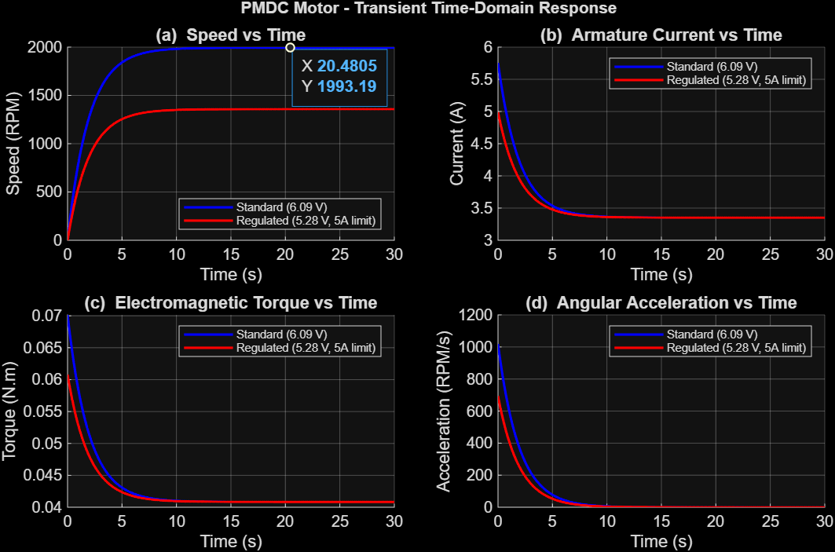
Figure 2: MATLAB transient time-domain response. Blue: standard (6.09 V); red: regulated (5.28 V). (a) Speed vs time. (b) Armature current vs time. (c) Electromagnetic torque vs time. (d) Angular acceleration vs time.

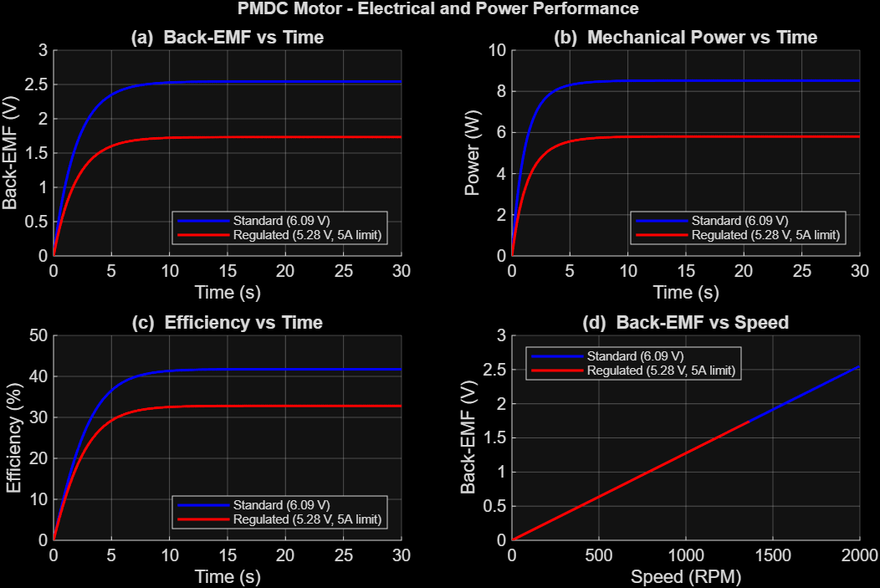
Figure 3: MATLAB electrical and power performance. (a) Back-EMF vs time. (b) Mechanical power vs time. (c) Efficiency vs time. (d) Back-EMF vs speed.

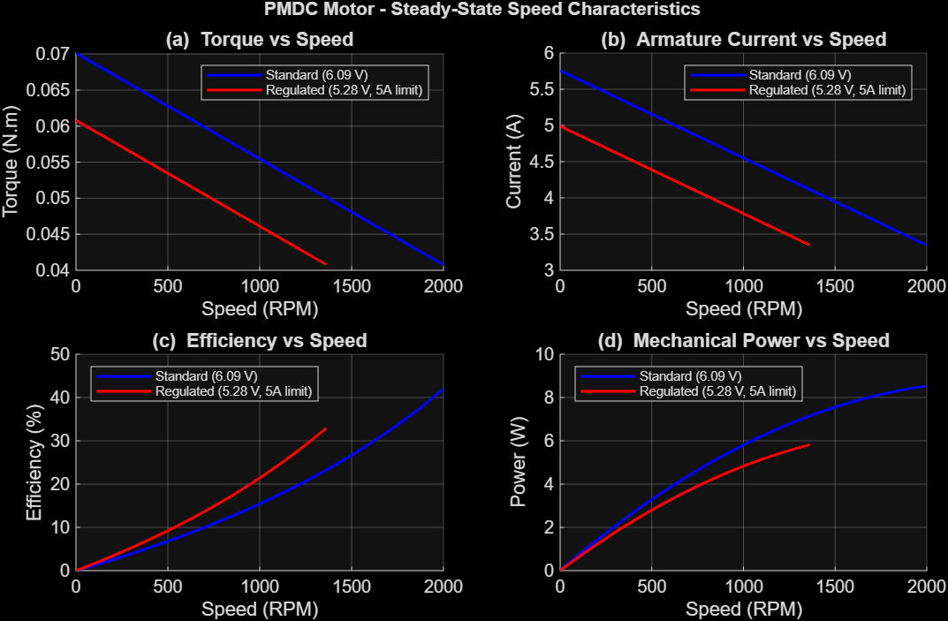
Figure 4: MATLAB steady-state speed characteristics. (a) Torque vs speed. (b) Armature current vs speed. (c) Efficiency vs speed. (d) Mechanical power vs speed.

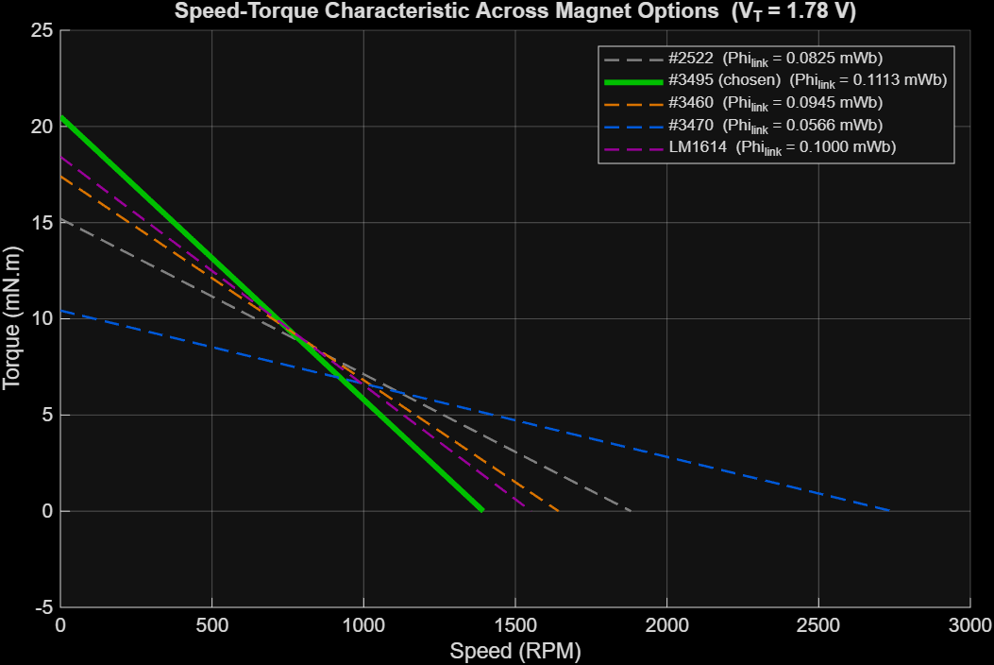Figure 5: Speed-torque characteristics across the five available magnets at $V_{T}$ = 1.78 V. Magnet #3495 (red) is the only option below the 2000 RPM safety ceiling.

The transient response exhibits the expected first-order behaviour. Speed rises monotonically from zero with a time constant of approximately 2.5 s, set by the electromechanical inertia $R_{A}$ * $J$ / ($K_{1}$ * $K_{2}$ * $Φ^{2}$). Armature current, torque, and angular acceleration all decay from their peak startup values as back-EMF develops, consistent with the self-regulating behaviour of a brushed DC machine (Chapman, 2012).
The regulated scenario successfully demonstrates supply-voltage limitation as a startup-current regulation mechanism. Reducing the supply from 6.09 V to 5.28 V caps the stall current at 4.99 A. The cost is a 635 RPM reduction in steady-state speed (1993 to 1358 RPM), and a 9-percentage-point drop in peak efficiency (41.8% to 32.8%).

7. Construction and Testing

7.1 Rotor and Winding Construction
Construction proceeded according to the parameters frozen at the end of the design phase. The 16-lamination rotor stack was mounted onto the supplied shaft with lamination teeth and slot openings aligned to within the 0.1 mm visual tolerance achievable with the available locating jig. Each of the eight coils was wound by hand from AWG 18 magnet wire, with turns counted on each coil to verify the 43-turn specification. Coils were inserted into slots with active sides forming the four-slot pitch dictated by the simplex lap winding schedule, and end-turns were dressed against the rotor faces to maintain clearance from the back-iron yoke.
Insulation integrity was confirmed at each stage. Slot bottoms were lined with thin polymer film before coil insertion, and a continuity check was performed between each coil and the rotor laminations after installation to verify no inadvertent contact. Each coil was tagged at its start, and finish ends during winding to support the subsequent connection schedule. These actions were taken to protect the wire from the sharp steel edges, prevent shorting, and for identifying different coils.

7.2 Commutator and Brush Assembly
The eight-segment commutator was fabricated from copper segments insulated by air gaps and mounted concentrically on the shaft. The brush blocks were prepared from carbon stock and held against the commutator by light spring pressure, with the brush separation set to span exactly one commutator segment at the neutral axis. Brush positions were chosen to place the brush pair perpendicular to the line joining the magnet centres, minimising commutation arcing under steady-state operation (Chapman, 2012).
During pre-test inspection, a 90-degree misalignment was identified between the commutator segment boundaries, and the coil ends of the lap winding. The commutator had been initially mounted with its segment boundaries aligned to the slot openings rather than to the inter-slot teeth, which would have caused brush short-circuits once commutation began. The commutator was unmounted, rotated 22.5 degrees (half a segment pitch), and reinstalled. This is an example of where the concurrent engineering process worked: the misalignment was caught at the design-to-build interface before testing, allowing correction at the cost of minutes rather than failed test runs.

7.3 Magnet and Back-Iron Installation
The pair of #3495 magnets was installed on the inside surface of the assembled back-iron yoke, with pole faces oriented toward the rotor outer surface and inter-magnet spacing set to position the magnet centres on a diameter through the rotor axis. The back-iron was secured to the motor base plate using the supplied mounting screws.
It is at this stage that the assembly error which dominated the test outcome arose. The back-iron yoke and stabilising plate were installed in inverted positions: the yoke (which should wrap over the magnets to complete the return path) was mounted underneath, and the stabilising plate (a non-magnetic component intended only to maintain assembly rigidity) was mounted above. The error was not detected at the time because the two components are similar in external appearance and the assembly checklist did not include a positive verification of back-iron orientation.

7.4 Quality Assurance
Each construction stage was followed by inspection against a written checklist, covering winding continuity, slot insulation integrity, commutator segment continuity and gap clearance, brush spring tension, magnet polarity orientation, and rotor freedom of rotation. The orientation of the back-iron components was not on the checklist, a gap that was the principal vulnerability of the assembly process and the primary driver of the priority-2 recommendation in Section 9.

7.5 Dynamometer Test
The constructed motor was tested against the laboratory dynamometer at the QUT electrical machines laboratory. Supply voltage was raised gradually from zero to identify the breakaway condition, then increased to 2.8 V, at which point a stable rotational steady state was achieved against the loaded dynamometer. Table 8 compares measured values with the regulated-scenario MATLAB predictions.

Quantity | Measured | Predicted (5.28 V) | Discrepancy
Supply voltage | 2.80 V | 5.28 V | -47% vs design
Armature current | 7.90 A | 4.99 A | +58% over limit
Rotational speed | 195 RPM | 1358 RPM | -86%
Output shaft torque | 1.45 mN·m | -- | Just above friction
Output mechanical power | 0.0296 W | 5.81 W | -99.5%
Overall efficiency | 0.134% | 32.8% | -99.6%
Table 8: Measured performance from the dynamometer test compared with the regulated-scenario MATLAB predictions.

The output shaft torque was calculated from the measured power and speed:
$$τ_{out} = \frac{P_{out}}{ω} = \frac{0.0296}{195×\frac{2π}{60}} = 1.45 mN·m$$
This exceeds the dynamometer's internal friction of 0.845 mN·m by a factor of approximately 1.7. The motor successfully self-started and overcame the minimum load requirement, albeit by a much smaller margin than designed. This confirms the winding, commutator, and brush assembly were fundamentally functional, and that the failure to meet performance targets is attributable to a single correctable assembly error.

8. Critical Evaluation

8.1 Comparison of Predicted and Measured Performance
The discrepancies in Table 8 are large enough that they cannot be attributed to ordinary modelling tolerances; they demand a structural rather than parametric explanation. The measured armature current of 7.9 A at 2.8 V exceeds even the unconstrained simulation prediction at a supply voltage more than twice as high. The measured speed represents only 14% of the design no-load speed. The measured efficiency is three orders of magnitude below the design prediction.

8.2 Root-Cause Analysis
No single parametric error in R_{a}, J, or K₁/K₂ can simultaneously explain elevated current, suppressed speed, and collapsed efficiency at this scale. The pattern points to a single underlying mechanism: near-total collapse of the air-gap flux density linking the armature winding.
When $ϕ$_{link} is reduced by an order of magnitude, the back-EMF at any given speed collapses correspondingly (since E_{a} = K₁ * $ϕ$_{link} * n), and the armature current is no longer regulated by back-EMF. The motor draws very high current at very low speed, exactly the pattern observed. The torque produced (τ_{ind} = K₂ * $ϕ$_{link} * I_{a}) remains only marginally above the dynamometer's friction load because the $ϕ$_{link} factor in the torque equation partially cancels the benefit of the elevated current.
The inverted back-iron installation is the structural cause of this flux collapse. With the yoke installed underneath rather than above the magnets, the high-permeability return path is absent. Magnetic flux must instead return through air, which has a relative permeability of approximately 10^3 times lower than mild steel. The effective magnetic circuit reluctance increases correspondingly, the flux crossing the air gap collapses, and $ϕ$_{link} falls from the design value of 0.111[mWb] to an estimated 0.005-0.010[mWb] based on back-calculated motor constants from the test data. This single fault accounts for all three observed deviations from the design predictions.

8.3 Process-Level Analysis
The failure in this project was not a design error; it was a process error. The electromagnetic design, winding methodology, and commutation scheme were all sound. The motor failed to meet its design targets because a component was installed in the wrong orientation at the design-to-construction handover.
This is precisely the class of failure the concurrent engineering workflow was intended to prevent. The weekly synchronisation reviews did catch the commutator-to-coil misalignment (Section 7.2), demonstrating the process could detect interface errors when the relevant components were actively reviewed. The back-iron orientation was not reviewed because no team member identified ahead of time that an ambiguity existed. The two components are visually similar, the brief did not specify orientation markings, and the assembly checklist did not include a verification step for this item.
The systemic lesson from this lapse in sufficient processing is that high-consequence interface decisions require deliberate process artefacts: orientation marks, labelled components, illustrated assembly checklists, and explicit sign-off at component handover points.

8.4 What the Test Confirmed
Despite the dominant failure mode, the test confirmed several positive outcomes. The motor was self-starting, produced measurable torque against the dynamometer, and the commutator and brush assembly functioned without severe sparking after the alignment correction. These results substantiate the claim that the electromagnetic design and construction were fundamentally sound. Correcting the back-iron orientation alone, with no other change, would be expected to restore the predicted 40% efficiency to within ordinary modelling tolerances.

8.5 Impact of Absent Intermediate Testing Sessions
A further contributing factor to the undiscovered assembly error was the absence of structured intermediate testing sessions throughout the construction phase. The group proceeded directly from component assembly to the final demonstration test, with no intermediate powered tests at key construction milestones. Had a simple no-load spin test been conducted after magnet and back-iron installation, the anomalously high current draw caused by the collapsed air-gap flux would have been immediately apparent. At the 2.8 V supply used during the final test, the predicted stall current for a correctly assembled motor is 1.68 A; the measured value of 7.9 A deviates from this by a factor of nearly five times, which any standard bench multimeter would have detected in seconds.
More broadly, structured intermediate testing enforces a system-level integration check at each stage of construction, catching errors that pass individual workstream quality checks in isolation. This is analogous to incremental integration testing in software development, where errors at interface boundaries are caught while the cost of correction remains low. A test plan with defined checkpoints, after winding, after commutator assembly, after back-iron installation, and before demonstration, would have provided four independent opportunities to detect the back-iron orientation error before it reached the test rig.

9. Recommendations and Future Work
Table 9 lists improvements ranked by expected impact on motor performance and process robustness.

# | Improvement | Impact | Justification
1 | Correct back-iron assembly orientation | Critical | Restores Phi_link to 0.111 mWb, recovering the predicted 1395 RPM and 40% efficiency. This single correction addresses the dominant failure mode.
2 | Pre-assembly component labelling and illustrated checklist | High | Orientation arrows on each back-iron component, a photograph-based step-by-step checklist, and sign-off from the design workstream would have prevented the error and will prevent recurrence.
3 | Improve commutator surface finish | Medium-high | Filling the gaps between commutator segments to form a smooth, continuous cylinder reduces brush bounce at higher RPM and improves electrical contact stability.
4 | Increase winding packing factor | Medium-high | A packing factor of 0.7-0.8 with machine-assisted winding would allow more conductors per slot, increasing K2 and available torque without additional wire.
5 | Reduce brush spring pressure | Medium-high | Lower contact force reduces mechanical friction between brushes and commutator, allowing the motor to reach higher rotational speeds for the same input power.
6 | Reduce air gap between back-iron and rotor | Medium | Reducing the air gap from 2.5 mm to approximately 1 mm would substantially lower magnetic circuit reluctance, increasing Phi_link. Enabled by the laser-cutting service on S-Block Level 9.
7 | Upgrade brush material to graphite composite | Medium | Lower contact resistance (currently dominating R_a at 1 Ohm) would improve electrical efficiency and reduce brush wear at higher speeds.
8 | Improve rotor mechanical balance | Low-medium | Machine-balancing the rotor would reduce mechanical losses from vibration, relevant at speeds approaching the 1395 RPM design point where imbalance forces scale with omega^2.
Table 9: Prioritised improvements ranked by expected impact.

9.1 Structured Intermediate Testing Protocol
As discussed in Section 8.5, the absence of intermediate testing was a direct contributing factor to the undetected back-iron assembly error. The recommended corrective action is to implement a structured test plan with four defined checkpoints and explicit pass/fail criteria: (1) after winding, verify coil-to-lamination insulation resistance exceeds 1 MOhm and individual coil resistance matches the calculated value within 5%; (2) after commutator assembly, confirm segment isolation and correct brush-to-neutral-axis alignment; (3) after back-iron and magnet installation, apply the design terminal voltage and verify that the no-load current and rising back-EMF with speed are within 20% of the model predictions; (4) before the demonstration test, conduct a full loaded run and log current and speed against simulation predictions. Checkpoint (3) would have detected the back-iron orientation error in the present project within minutes of bench testing, well before the demonstration date.

9.2 Future Work
Three further investigations would extend the design beyond the scope of this project. First, a second test run on the corrected motor would close the loop on the principal design hypothesis, since the analytical and simulation models predict constraint-compliant performance and this prediction remains untested in a correctly assembled motor. Second, a more accurate magnetic circuit model incorporating finite leakage between magnet pole faces, back-iron saturation, and the discrete yoke geometry would refine the Phi_link estimate and reduce the conservatism of the 50% leakage assumption (Fitzgerald, Kingsley & Umans, 2003). Third, extending the MATLAB simulation to incorporate dynamic load variation (fan torque scaling with n^2) would provide a more realistic performance prediction for the target application and could support the design of a simple speed-control strategy (Hughes, 2019).

10. Reflective Review
The project produced a working prototype motor that did not meet its quantitative performance targets but, through that failure, surfaced a clear process lesson. The failure was not in the design, the modelling, the winding, or the commutation, it was in the installation of two components whose orientation was visually ambiguous, and which the team's process did not explicitly disambiguate. The cost of preventing this class of error is small (orientation marks, illustrated checklists, deliberate handover sign-off); the cost of not preventing it was, in this instance, the difference between a 40% efficient machine and a 0.13% efficient one.
Beyond this, the project confirmed the value of the concurrent engineering approach at the design and computational levels. The Excel interface acting as the canonical specification document eliminated an entire class of failure mode in which parallel workstreams develop incompatible parameter interpretations. The weekly synchronisation reviews caught the commutator misalignment before testing. The MATLAB simulation produced predictions that agree with the Excel model and would be expected to agree with measured performance in a correctly assembled motor.
The team's contributions were distributed across the three workstreams defined in Section 4.1. All five members contributed to the physical assembly and dynamometer test session. Documentation responsibilities were distributed in proportion to workstream involvement, with each member taking primary responsibility for the sections most closely related to their contributions.

11. Conclusion
This report has documented the design, construction, and evaluation of a brushed PMDC motor as a scaled prototype for a compact desktop cooling fan. The design process produced a self-consistent and constraint-compliant specification, 8 coils, 43 turns of AWG 18 wire, magnet #3495, and an armature resistance of 1.0578 Ohm, satisfying all five compliance flags and predicting a peak efficiency of 40% at the design operating point. The MATLAB Forward Euler simulation characterised transient behaviour across two voltage scenarios, and the complementary sensitivity study confirmed that magnet #3495 was the only candidate satisfying the 2000 RPM no-load speed constraint at the design terminal voltage.
The physical motor demonstrated successful self-start under load and produced measurable rotation, confirming the fundamental soundness of the electromagnetic design, winding methodology, and commutation scheme. An assembly error, the back-iron yoke and stabilising plate installed in inverted positions, collapsed the effective air-gap flux density by an order of magnitude, suppressing the back-EMF self-regulation mechanism and reducing the overall efficiency to 0.134%, three orders of magnitude below the design prediction. Root-cause analysis shows this single error consistently explains all observed deviations from predicted performance; no correction to the underlying electromagnetic model is required.
The highest-priority recommendation for any future build is to add orientation markings, illustrated checklists, and a design-side sign-off at the assembly stage to defend against this class of communication failure. With these mitigations and the correct back-iron orientation in place, the analytical and simulation models predict constraint-compliant performance with substantial margin.

References
Chapman, S. J. (2012). Electric machinery fundamentals (5th ed.). McGraw-Hill.
Chapra, S. C., & Canale, R. P. (2015). Numerical methods for engineers (7th ed.). McGraw-Hill.
Fitzgerald, A. E., Kingsley, C., & Umans, S. D. (2003). Electric machinery (6th ed.). McGraw-Hill.
Hughes, A. (2019). Electric motors and drives: Fundamentals, types and applications (5th ed.). Newnes/Elsevier.
Mohan, N., Undeland, T. M., & Robbins, W. P. (2003). Power electronics: Converters, applications, and design (3rd ed.). John Wiley & Sons.
Queensland University of Technology. (2025). EGB241 DC Motor Building Assignment description. QUT Canvas.

Appendix A, Initial Design Sketches
Figures A1-A4 reproduce the initial hand-drawn design sketches developed during early design discussions, used to communicate the rotor, commutator, and back-iron concepts between workstreams before commitment to the detailed Excel parameterisation and physical construction.

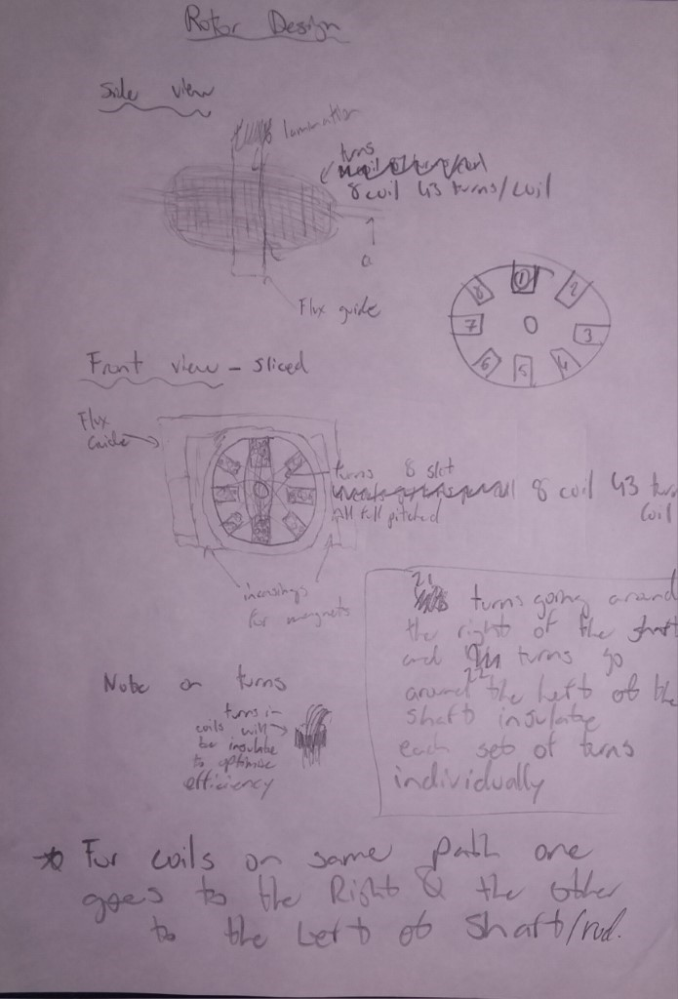
Figure A1: Initial rotor design sketch. Side and front views showing the 8-slot lamination geometry, 43-turn coils, flux guide envelope, and coil-side routing convention.

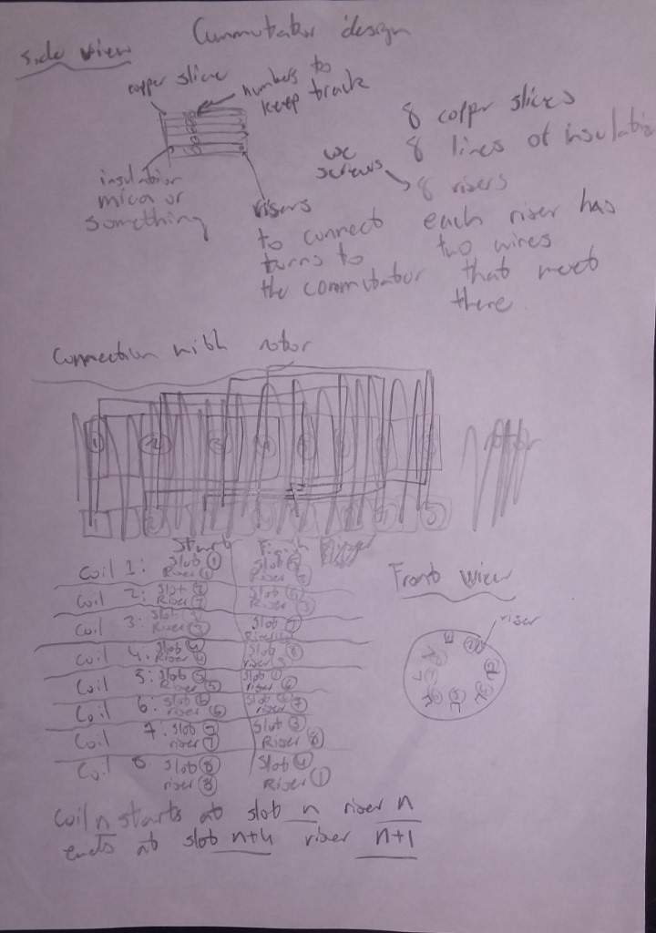
Figure A2: Initial commutator and brush assembly sketch. Shows the 8-segment commutator with brush positions perpendicular to the line joining the two magnet centres.

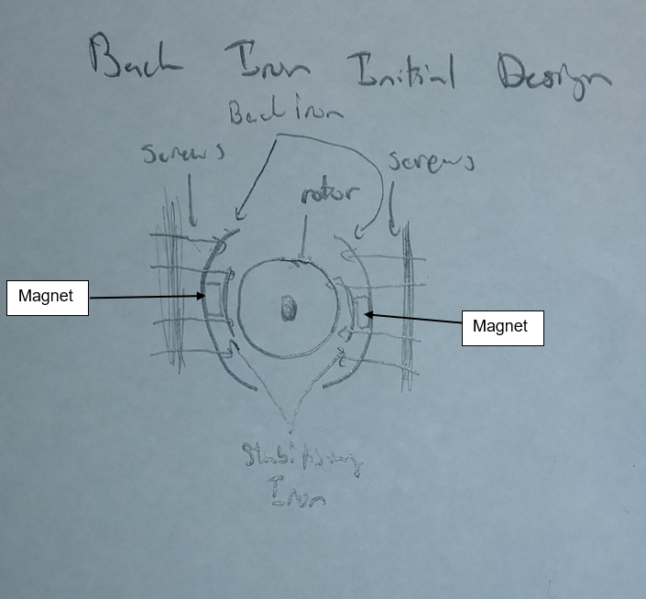
Figure A3: Initial back-iron design sketch. Shows the steel lamination yoke geometry, 3.6 mm wall thickness, and the intended orientation of the yoke relative to the magnet pair and rotor outer surface.

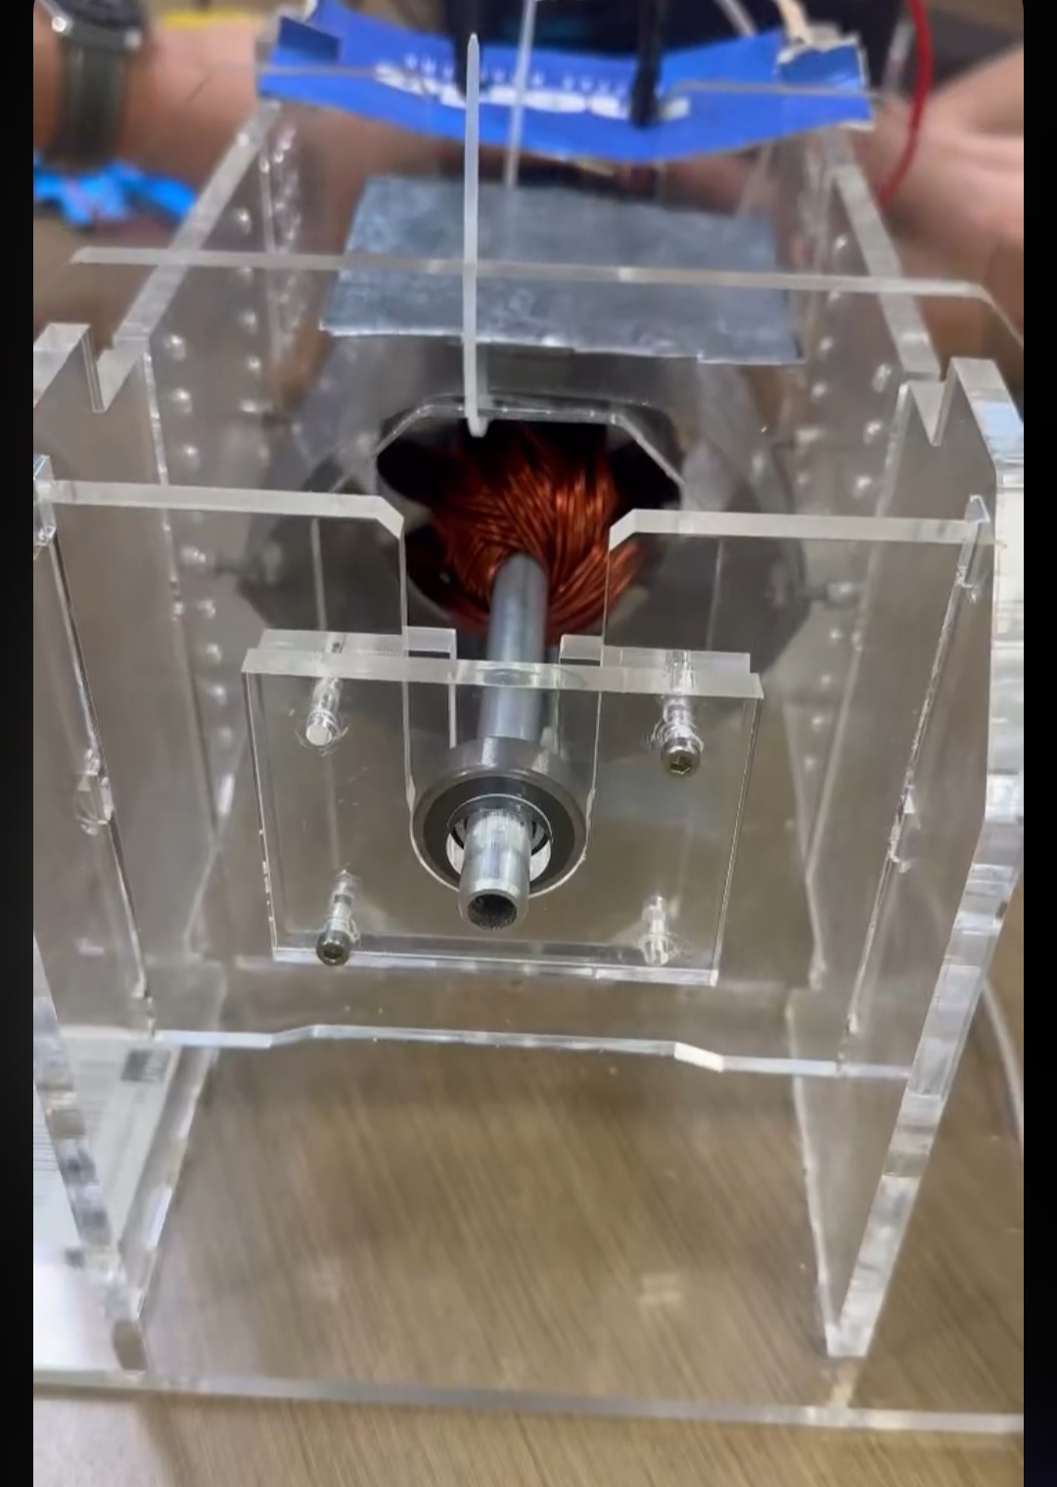
Figure A4: Final assembled motor configuration (Front View) as tested against the laboratory dynamometer.

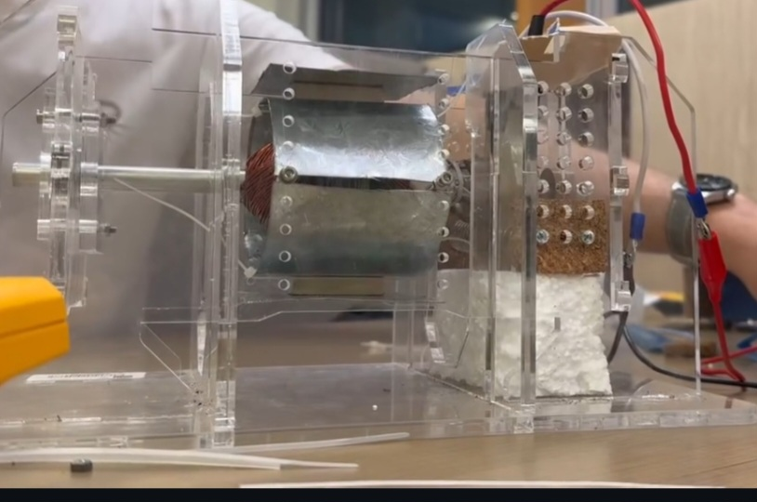
Figure A5: Final assembled motor configuration (Side View) as tested against the laboratory dynamometer.

Appendix B, MATLAB Source Code
The complete Forward Euler MATLAB script used to generate Figures 2-5 is reproduced below. The script includes an input prompt for interactive supply-voltage entry, a disp call to confirm the input back to the user, and sprintf for legend label construction and the formatted command-window summary. The multi-magnet flux-density sweep in Section 9 of the script produces Figure 5, addressing the brief's requirement for speed-torque characteristics across different field flux densities.

SECTION 1 - Final Motor Design Parameters (Group 20)
Rrotor = 30; % Outer rotor radius (mm)
Wslot = 8; % Slot width (mm)
Aslot = 120; % Slot cross-section (mm^2)
Nslot = 8; % Number of rotor slots
Lrotor = 19.2; % Rotor stack length (mm) - 16 x 1.2 mm laminations

% Winding geometry (mm)
Lwire = 44169.6; % Total wire length (mm) - 8 coils x 43 turns x 128.4 mm/turn
Dwire = 1.024; % Wire conductor diameter (mm) - AWG 18

% Electromagnetic constants
K1 = 11.47; % EMF motor constant (Z/60 = 688/60)
K2 = 109.50; % Torque motor constant (Z*p / 2*pi*a = 688*2 / (2*pi*2))
Ra = 1.0578; % Armature resistance (Ohm) - includes 1 Ohm brush resistance
phi = 0.11127e-3; % Flux linkage (Wb) - 50% leakage: 0.5 * 0.22254e-3

% Applied load torque (N.m)
tauLoad = 0.040845; % Dynamometer loaded torque (40 mN.m brake + 0.845 mN.m friction)

SECTION 2 - Rotor Moment of Inertia
Arotor = pi*Rrotor^2 - pi*(Wslot/2)^2;
Asteel = Arotor - Nslot*Aslot;
Acopper = pi*(Dwire/2)^2;

Vsteel = Asteel * Lrotor; % mm^3
Vcopper = Acopper * Lwire; % mm^3

densitySteel = 7850 / 1000^3; % kg/mm^3
densityCopper = 8960 / 1000^3; % kg/mm^3

massSteel = Vsteel * densitySteel;
massCopper = Vcopper * densityCopper;
massRotor = massSteel + massCopper;

R1 = (Wslot/2) / 1000; % Inner radius (m)
R2 = Rrotor / 1000; % Outer radius (m)
J = 0.5 * massRotor * (R1^2 + R2^2);

disp('=== Rotor Inertia ===');
disp(sprintf('Rotor mass : %.6f kg', massRotor));
disp(sprintf('Inertia J : %.4e kg.m^2', J));
disp(' ');

SECTION 3 - Interactive Voltage Selection
disp('--- Voltage Scenario Setup ---');
V_input = input('Enter standard supply voltage in V [press Enter for 6.09 V]: ');
if isempty(V_input)
V_standard = 6.09;
else
V_standard = V_input;
end
disp(sprintf('Standard supply voltage set to: %.2f V', V_standard));

Ia_limit = 5.0;
V_regulated = (Ia_limit * Ra) - 0.01;
disp(sprintf('Regulated supply voltage (5 A startup limit): %.2f V', V_regulated));
disp(' ');

Vsupply_list = [V_standard, V_regulated];
nV = length(Vsupply_list);

legendLabels = {sprintf('Standard (%.2f V)', V_standard), ...
sprintf('Regulated (%.2f V, 5A limit)', V_regulated)};
colors = {'b', 'r'};

% Simulation time parameters
sim_time = 30;
timesteps = 1000;
dt = sim_time / timesteps;
t = linspace(0, sim_time, timesteps);

SECTION 4 - Pre-Allocate Result Matrices
nm_mat = zeros(nV, timesteps);
Ia_mat = zeros(nV, timesteps);
Ea_mat = zeros(nV, timesteps);
tauInd_mat = zeros(nV, timesteps);
Alpha_mat = zeros(nV, timesteps);
Pmech_mat = zeros(nV, timesteps);
Pload_mat = zeros(nV, timesteps);
Efficiency_mat = zeros(nV, timesteps);

SECTION 5 - Forward Euler Time-Domain Simulation
for i = 1:nV
Vs = Vsupply_list(i);

% Initial conditions (motor at standstill, no back-EMF)
Ea_mat(i,1) = 0;
Ia_mat(i,1) = Vs / Ra;
tauInd_mat(i,1) = K2 * phi * Ia_mat(i,1);
Alpha_mat(i,1) = ((tauInd_mat(i,1) - tauLoad) / J) * (60 / (2*pi));

for k = 2:timesteps
nm_mat(i,k) = nm_mat(i,k-1) + Alpha_mat(i,k-1) * dt;
Ea_mat(i,k) = K1 * phi * nm_mat(i,k);
Ia_mat(i,k) = (Vs - Ea_mat(i,k)) / Ra;
tauInd_mat(i,k) = K2 * phi * Ia_mat(i,k);
Alpha_mat(i,k) = ((tauInd_mat(i,k) - tauLoad) / J) * (60 / (2*pi));
end

% Performance metrics
Pmech_mat(i,:) = tauInd_mat(i,:) .* (2*pi/60) .* nm_mat(i,:);
Pelec = Vs .* Ia_mat(i,:);
Pload_mat(i,:) = tauLoad .* (2*pi/60) .* nm_mat(i,:);

% eps prevents division by zero at t=0 when motor is at standstill
Efficiency_mat(i,:) = Pload_mat(i,:) ./ max(Pelec, eps) * 100;
end

SECTION 6 - Figure 1: Transient Time-Domain Response
figure;
sgtitle('PMDC Motor - Transient Time-Domain Response', 'FontWeight', 'bold', 'FontSize', 10);

subplot(2,2,1); hold on; grid on;
for i = 1:nV
plot(t, nm_mat(i,:), colors{i}, 'LineWidth', 1.5);
end
title('(a) Speed vs Time'); xlabel('Time (s)'); ylabel('Speed (RPM)');
legend(legendLabels, 'Location', 'southeast', 'FontSize', 7);

subplot(2,2,2); hold on; grid on;
for i = 1:nV
plot(t, Ia_mat(i,:), colors{i}, 'LineWidth', 1.5);
end
title('(b) Armature Current vs Time'); xlabel('Time (s)'); ylabel('Current (A)');
legend(legendLabels, 'Location', 'northeast', 'FontSize', 7);

subplot(2,2,3); hold on; grid on;
for i = 1:nV
plot(t, tauInd_mat(i,:), colors{i}, 'LineWidth', 1.5);
end
title('(c) Electromagnetic Torque vs Time'); xlabel('Time (s)'); ylabel('Torque (N.m)');
legend(legendLabels, 'Location', 'northeast', 'FontSize', 7);

subplot(2,2,4); hold on; grid on;
for i = 1:nV
plot(t, Alpha_mat(i,:), colors{i}, 'LineWidth', 1.5);
end
title('(d) Angular Acceleration vs Time'); xlabel('Time (s)'); ylabel('Acceleration (RPM/s)');
legend(legendLabels, 'Location', 'northeast', 'FontSize', 7);

SECTION 7 - Figure 2: Electrical and Power Performance
figure;
sgtitle('PMDC Motor - Electrical and Power Performance', 'FontWeight', 'bold', 'FontSize', 10);

subplot(2,2,1); hold on; grid on;
for i = 1:nV
plot(t, Ea_mat(i,:), colors{i}, 'LineWidth', 1.5);
end
title('(a) Back-EMF vs Time'); xlabel('Time (s)'); ylabel('Back-EMF (V)');
legend(legendLabels, 'Location', 'southeast', 'FontSize', 7);

subplot(2,2,2); hold on; grid on;
for i = 1:nV
plot(t, Pmech_mat(i,:), colors{i}, 'LineWidth', 1.5);
end
title('(b) Mechanical Power vs Time'); xlabel('Time (s)'); ylabel('Power (W)');
legend(legendLabels, 'Location', 'southeast', 'FontSize', 7);

subplot(2,2,3); hold on; grid on;
for i = 1:nV
plot(t, Efficiency_mat(i,:), colors{i}, 'LineWidth', 1.5);
end
title('(c) Efficiency vs Time'); xlabel('Time (s)'); ylabel('Efficiency (%)');
legend(legendLabels, 'Location', 'southeast', 'FontSize', 7);

subplot(2,2,4); hold on; grid on;
for i = 1:nV
plot(nm_mat(i,:), Ea_mat(i,:), colors{i}, 'LineWidth', 1.5);
end
title('(d) Back-EMF vs Speed'); xlabel('Speed (RPM)'); ylabel('Back-EMF (V)');
legend(legendLabels, 'Location', 'northwest', 'FontSize', 7);

SECTION 8 - Figure 3: Steady-State Speed Characteristics
figure;
sgtitle('PMDC Motor - Steady-State Speed Characteristics', 'FontWeight', 'bold', 'FontSize', 10);

subplot(2,2,1); hold on; grid on;
for i = 1:nV
plot(nm_mat(i,:), tauInd_mat(i,:), colors{i}, 'LineWidth', 1.5);
end
title('(a) Torque vs Speed'); xlabel('Speed (RPM)'); ylabel('Torque (N.m)');
legend(legendLabels, 'Location', 'northeast', 'FontSize', 7);

subplot(2,2,2); hold on; grid on;
for i = 1:nV
plot(nm_mat(i,:), Ia_mat(i,:), colors{i}, 'LineWidth', 1.5);
end
title('(b) Armature Current vs Speed'); xlabel('Speed (RPM)'); ylabel('Current (A)');
legend(legendLabels, 'Location', 'northeast', 'FontSize', 7);

subplot(2,2,3); hold on; grid on;
for i = 1:nV
plot(nm_mat(i,:), Efficiency_mat(i,:), colors{i}, 'LineWidth', 1.5);
end
title('(c) Efficiency vs Speed'); xlabel('Speed (RPM)'); ylabel('Efficiency (%)');
legend(legendLabels, 'Location', 'northwest', 'FontSize', 7);

subplot(2,2,4); hold on; grid on;
for i = 1:nV
plot(nm_mat(i,:), Pmech_mat(i,:), colors{i}, 'LineWidth', 1.5);
end
title('(d) Mechanical Power vs Speed'); xlabel('Speed (RPM)'); ylabel('Power (W)');
legend(legendLabels, 'Location', 'northwest', 'FontSize', 7);

SECTION 9 - Figure 4: Multi-Magnet Speed-Torque Characteristics
magnetNames = {'#2522', '#3495 (chosen)', '#3460', '#3470', 'LM1614'};
magnetPhiLink = [0.0825, 0.1113, 0.0945, 0.0566, 0.1000] * 1e-3; % Wb
VT_design = 1.78; % Conservative Excel design voltage (V)

% --- Figure 4 visual style ---
% Chosen magnet (#3495, index 2): solid bright green, thick line
% All others: dashed, thinner, distinct non-green/non-purple colours
magnetColors = {[0.5 0.5 0.5], [0 0.75 0], [0.85 0.45 0], [0 0.35 0.85], [0.6 0 0.6]};
magnetLineStyle = {'--', '-', '--', '--', '--'};
magnetLineWidth = [1.2, 2.8, 1.2, 1.2, 1.2];

% Compute torque-speed line for each magnet from n = 0 to its n_max
figure;
hold on; grid on;
sweepLegend = cell(1, length(magnetPhiLink));
for m = 1:length(magnetPhiLink)
phiM = magnetPhiLink(m);
nMaxM = VT_design / (K1 * phiM); % RPM at zero torque
nSweep = linspace(0, nMaxM, 200);
tauSweep = K2 * phiM * (VT_design - K1 * phiM * nSweep) / Ra;
plot(nSweep, tauSweep * 1000, ... % convert to mN.m
'Color', magnetColors{m}, ...
'LineStyle', magnetLineStyle{m}, ...
'LineWidth', magnetLineWidth(m));
sweepLegend{m} = sprintf('%s (Phi_{link} = %.4f mWb)', ...
magnetNames{m}, phiM*1e3);
end
xlabel('Speed (RPM)');
ylabel('Torque (mN.m)');
title(sprintf('Speed-Torque Characteristic Across Magnet Options (V_T = %.2f V)', VT_design));
legend(sweepLegend, 'Location', 'northeast', 'FontSize', 8);

SECTION 10 - Command Window Summary
disp('=== Simulation Summary ===');
disp(sprintf('Standard voltage : %.2f V', V_standard));
disp(sprintf('Regulated voltage : %.2f V (%.1f A startup limit)', V_regulated, Ia_limit));
disp(' ');

summaryHeader = sprintf('%-38s %-12s %-12s %-14s', ...
'Scenario', 'Final RPM', 'Peak Ia (A)', 'Final Eff (%)');
disp(summaryHeader);
disp(repmat('-', 1, length(summaryHeader)));
for i = 1:nV
rowStr = sprintf('%-38s %-12.2f %-12.2f %-14.2f', ...
legendLabels{i}, nm_mat(i,end), Ia_mat(i,1), Efficiency_mat(i,end));
disp(rowStr);
end
Published with MATLAB® R2025b

